G VENKATA SRIDHAR  gvsridhar.devops@gmail.com
+91-9739964629

KUBERNETES
What is Kubernetes?
- Kubernetes is the Greek word for helmsman or captain of a ship
- Kubernetes is also referred to as k8s, as there are 8 characters between k and s
- Container management (orchestration) tool, developed by Google lab (& later donated to CNCF) and it is an open source written on Golang also called K8S

Container Management / Orchestration Tool
- Container Orchestration tool or engine automates deploying, scaling and managing the containerized application on a group of servers
Example:
- Kubernetes
- Docker Swarm
- Apache Mesos Marathon

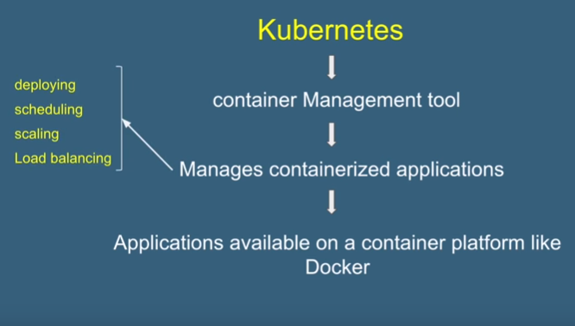

What Is Docker?
- Docker is a tool designed to make it easier to deploy and run applications by using Containers.
- In docker, containers allow a developer to package up an application with all of the parts it needs, such as libraries and other dependencies, and ship it all out as one package.
- Organizations have to use multiple containers to Ensure availability, Load balancing, Scale-up and down based on user load.
- Deploying
- Scheduling
- Scaling
- Load Balancing
- Batch Execution
- Rollbacks
- Monitoring
- This is called as “Container Orchestration Engine” which “Manages Containerized Apps”
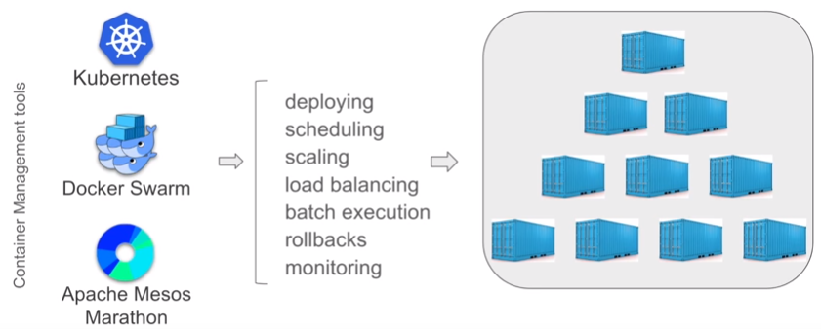

Docker - Creates Containers
Kubernetes - Manages Containers

What are the features of Kubernetes?
Automatic Bin Packing
- Automatically places containers based on their resource requirements like CPU & Memory (RAM), while not sacrificing availability and saves resources.

Service Discovery & Load Balancing
- Kubernetes gives Pods their own IP addresses and a single DNS name for a set of Pods, and can load-balance across them.
- With this system, Kubernetes has control over network and communication between pods and can load balance across them.

Storage Orchestration
- Kubernetes allows to mount the storage system of your choice
Local
Cloud (AWS – Amazon Web Services)
Network (NFS – Network File System)

Self-Healing
- If a container fails - restarts container.
- If node dies - replaces and reschedule containers on other nodes.
- If container does not respond to user defined health check - kills container.
- This is taken care by Kubernetes ReplicationController.

Automated Rollouts and Rollbacks
- Rollout: deploy changes to the application or its configuration.
- Rollback: revert the changes & restore to the previous state.
- Kubernetes ensures there is no downtime during this process.

Secret & Configuration Management
- Kubernetes manages secrets and configuration details for an application separately from the container image,
- Deploy and update secrets and application configuration without rebuilding your image and without exposing secrets in your stack configuration.

Batch Execution
- Kubernetes supports batch execution, long-running jobs, and replaces failed containers

Horizontal Scaling
- In Kubernetes, we can scale up or down the containers
- Using Commands
- From the Dashboard (Kubernetes UI)
- Automatically based on CPU Usage

Cluster: When you deploy Kubernetes, you get a cluster
Node: A cluster is a set of machines, called nodes
- A cluster has at least one worker node and at least one master node
- In earlier days of Kubernetes, worker nodes were called minions
- In Kubernetes, every cluster has at least one master node and at least one worker node
- There can be more than one master nodes in a cluster to provide a cluster with failover and high availability
- There can be multiple clusters in Kubernetes Architecture

- The worker node(s) host the pods that are the components of the application
- The master node(s) manages the worker nodes and the pods in the cluster

In a Cluster Kubernetes supports:
- No more than 5000 nodes
- No more than 150000 total pods
- No more than 300000 total containers
- No more than 100 pods per node

4 Components of Master node
- API Server - for all communications ( JSON over HTTP API)
- Scheduler - schedules pods on nodes
- Controller Manager - runs controllers
- Etcd - open source, distributed key-value database from CoreOS

3 Components of Worker node
- kubelet
- kube-proxy
- Container runtime

- Addons for DNS, Dashboard, monitoring, logging etc
- You can install and use Kubernetes on a personal computer/laptop, on any physical/virtual machine or servers, as a cloud service

Kubernetes Playground
https://www.katacoda.com/courses/kubernetes/playground

Play with K8s
https://labs.play-with-k8s.com/

Play with Kubernetes Classroom
https://training.play-with-kubernetes.com/

Kubernetes installation tools
Minikube - https://kubernetes.io/docs/setup/learning-environment/minikube/
Kubeadm - https://kubernetes.io/docs/setup/production-environment/tools/kubeadm/create-cluster-kubeadm/

Cloud based Kubernetes services
- GKE - Google Kubernetes Engine
- AKS - Azure Kubernetes Service
- Amazon EKS (Elastic Kubernetes Service)

Step 1: Add new instance
Step 2: Initialize master node
Step 3: Add another instance
- kubectl get nodes
- kubectl get pods
- kubectl get services
Step 4: Join the instance as worker to the cluster
Step 5: Run kubectl run command to start container in a pod
- kubectl run nginx --image=nginx

References: https://kubernetes.io/docs/reference/generated/kubectl/kubectl-commands#run

What is Play with K8s?
- Create a master node
- Create a worker node
- Join worker node to master
- Run a container in a pod
- Everything on browser. No installation or setup required
- 4 hrs time limit | Max instances 8
- To Login use GitHub or Docker Account

What is Minikube step by step with the help of images open-source tool?
- To run Kubernetes locally on your system runs a single-node Kubernetes cluster inside a VM on your system.
- Minikube is a tool that helps to create a single node Kubernetes cluster running in a VM on top of your laptop
References: https://kubernetes.io/docs/setup/learning-environment/minikube/

How to run Kubernetes via Minikube
- Basic Commands:
MINIKUBE | KUBERNETES
- minikube version  - minikube help  - minikube start  - minikube status  - minikube service  - minikube stop  - minikube delete | - kubectl get nodes  - kubectl get pods  - kubectl create  - kubectl expose  - kubectl delete
References: https://kubernetes.io/docs/tasks/tools/install-minikube/

How to install Minikube on Mac OS
STEPS: Check - Virtualization is supported
Step 1: Install kubectl
- brew install kubectl
Step 2: Install hyperkit (virtual box, VMware fusion)
- brew install hyperkit
Step 3: Install minikube
- brew install minikube
- minikube version
- minikube help
Step 4: Start minikube
- minikube start
- minikube status
- kubectl get nodes
- kubectl get pods

Start/Run Kubernetes via Minikube
Step 1: Create a Kubernetes Deployment using an existing image
- kubectl create deployment hello-minikube --image=k8s.gcr.io/echoserver:1.10
Step 2: Expose the deployment as a service
- kubectl expose deployment hello-minikube --type=NodePort --port=8080
Step 3: Check the nodes and pods
- kubectl get nodes
- kubectl get pods
Step 4: Get URL of the service
- minikube service hello-minikube --url
Step 5: Delete service and deployment
- kubectl delete services hello-minikube
- kubectl delete deployment hello-minikube
Step 6: Stop minikube cluster
- minikube stop
Step 7: Delete minikube cluster
- minikube delete

Quick Introduction to Kubernetes
- Kubernetes, if you are not aware, is an open-source system for automating deployment, scaling, and managing containerized applications. With this platform, you can decompose your applications into smaller systems (called MicroServices) while developing; then you can compose (or orchestrate) these systems together while deploying. As you will learn, Kubernetes provides you different objects that help you organize your applications' microservices into logical units that you can easily manage.
- The explanation above, while correct, is probably too vague and too abstract if you are not familiar with Kubernetes and microservices. Therefore, as the goal of this article is to avoid this kind of introduction, you will be better off getting started soon.

How to Spin Up a Kubernetes Cluster
- Currently, several services around the globe provide different Kubernetes implementations. Among the most popular ones, you will find:
- Minikube: An open-source tool that you can install in your local machine to use Kubernetes locally. This tool uses a virtualization solution (like VirtualBox or similar) to set up a local Kubernetes cluster.
- Google Kubernetes Engine (GKE): Google's solution that manages production-ready Kubernetes clusters for you.
- Amazon Elastic Kubernetes Service (EKS): Amazon's solution that manages production-ready Kubernetes clusters for you.
- Azure Kubernetes Service (AKS): Azure's solution that provides you managed production-ready Kubernetes clusters.
- OpenShift Kubernetes: Red Hat's solution that handles Kubernetes clusters for you.
Note: Minikube is the only solution that is free forever (but it is also not that useful, as it runs locally only). Although some of the other solutions offer free tiers that will allow you to get started without paying a dime, they will charge you money to keep your clusters running eventually.

Why Choose DigitalOcean
- You might have noticed that the list above did not mention DigitalOcean, even though this article stated that you would use it. The thing is, DigitalOcean just launched its Managed Kubernetes Service, and this service are still on a limited availability mode.
- What this means is that DigitalOcean Kubernetes provides full functionality, offers ample support, but that this service is partially production-ready (errors might occur). For this article, though, the current offering is robust enough. Besides that, you will see a referral link in this article that will give you a $100 USD, 60-day credit on DigitalOcean so you can spin up your cluster without paying anything.

Installing Kube Control (kubectl)
- Before spinning up a Kubernetes cluster, you will need a tool called kubectl. This tool, popularly known as "Kube Control", is a command-line interface that will allow you to manage your Kubernetes cluster with ease from a terminal. Soon, you will be quite acquainted with kubectl.
- To install kubectl, you can head to this resource and choose, from the list shown, the instructions for your operating system. In this list, you will see instructions for:
- Linux (and some of its variations, like Ubuntu);
- MacOS (which can be accomplished by using Homebrew or Macports);
- Moreover, Windows (which you will find instructions or PowerShell and Chocolatey).

After following these instructions and installing kubectl in your machine, you can issue the following command to confirm that the tool is indeed available:
kubectl version++
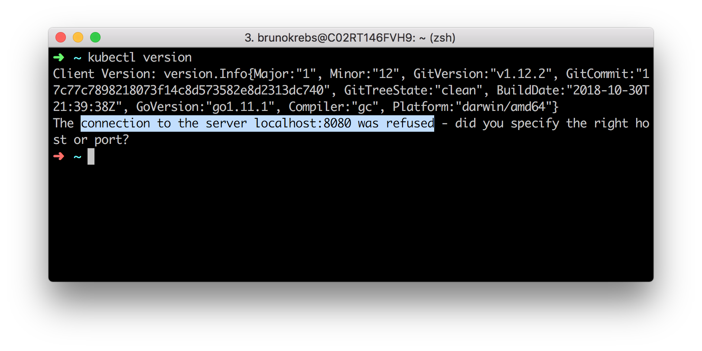
The output of the above command will show the client version (i.e., the release of kubectl) and a message saying that the "connection to the server localhost:8080 was refused." What this means is that you do have kubectl properly installed, but that you do not have a cluster available yet (expected, right?). In the next sections, you will learn how to spin up a Kubernetes cluster.

How to Create a Kubernetes Cluster on DigitalOcean
- If you already have a Kubernetes cluster that you will use, you can skip this section. Otherwise, please, follow the instructions here to create your Kubernetes cluster on DigitalOcean. For starters, as mentioned before, you will have to use this referral link. If you do not use a referral link, you will end up paying for your cluster from the very begin.
- After using this link to create your account on DigitalOcean, you will get an email confirmation. Use the link sent to you to confirm your email address. Confirming your address will make DigitalOcean ask you for a credit card. Do not worry about this. If you do not spend more than $100 USD, they will not charge you anything.
- After inputting a valid credit card, you can use the next screen to create a project, or you can use this link to skip this unnecessary step and to head to the Kubernetes dashboard.
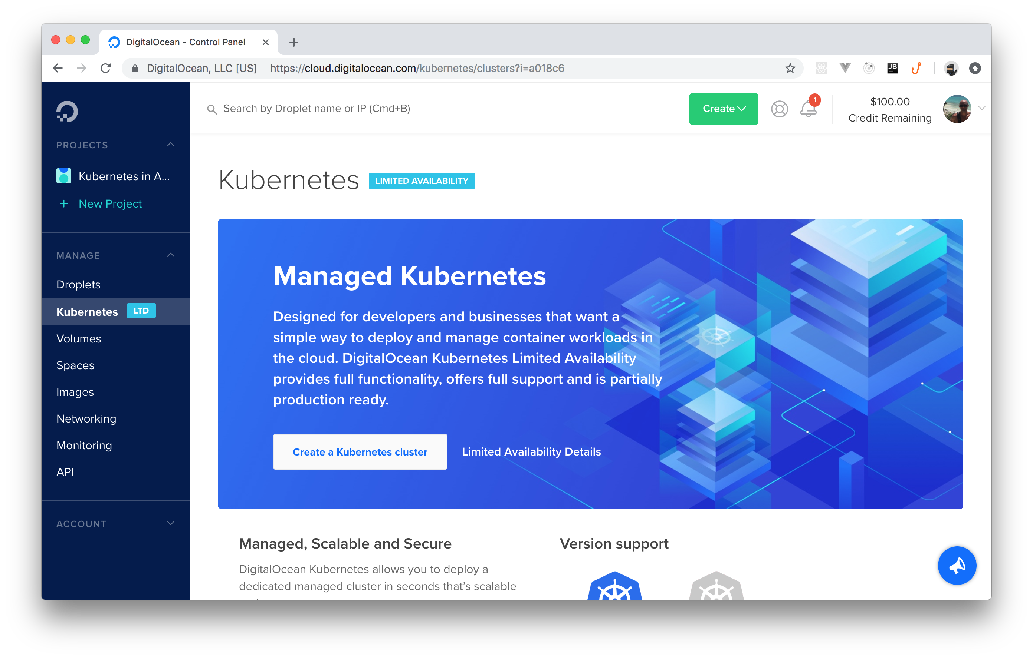
From the Kubernetes dashboard, you can hit the Create a Kubernetes cluster button (you might have to click on Enable Limited Access first). Then, DigitalOcean will show you a new page with a form that you can fill in as follows:
Select a Kubernetes version: The instructions on this article were tested with the
1.13.5-do.1 version. If you feel like testing other versions, feel free to go ahead. Just let us know how it went.
Choose a datacenter region: Feel free to choose whatever region you prefer.
Add node pool(s): Make sure you have just one node pool, that you choose the $10/Month per node option, and that you have at least three nodes.
Add Tags: Do not worry about tagging anything.
Choose a name: You can name your cluster whatever you want (e.g., "Kubernetes-tutorial"). Just make sure DigitalOcean accepts the name (e.g., names cannot contain spaces).

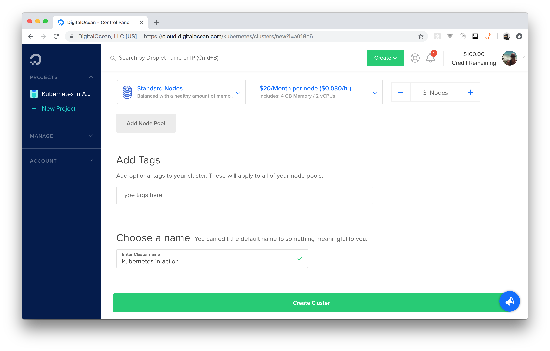
- After filling in this form, you can click on the Create Cluster button. It will take a few minutes (roughly 4 minutes) before DigitalOcean finishes creating your cluster for you. However, you can already download the cluster's config file.
- This file contains the credentials needed for you to act as the admin of the cluster, and you can find it on the cluster's dashboard. After you clicked on the Create Cluster button, DigitalOcean redirected you to your cluster's dashboard. From there, if you scroll to the bottom, you will see a button called Download Config File. Click on this button to download the config file.
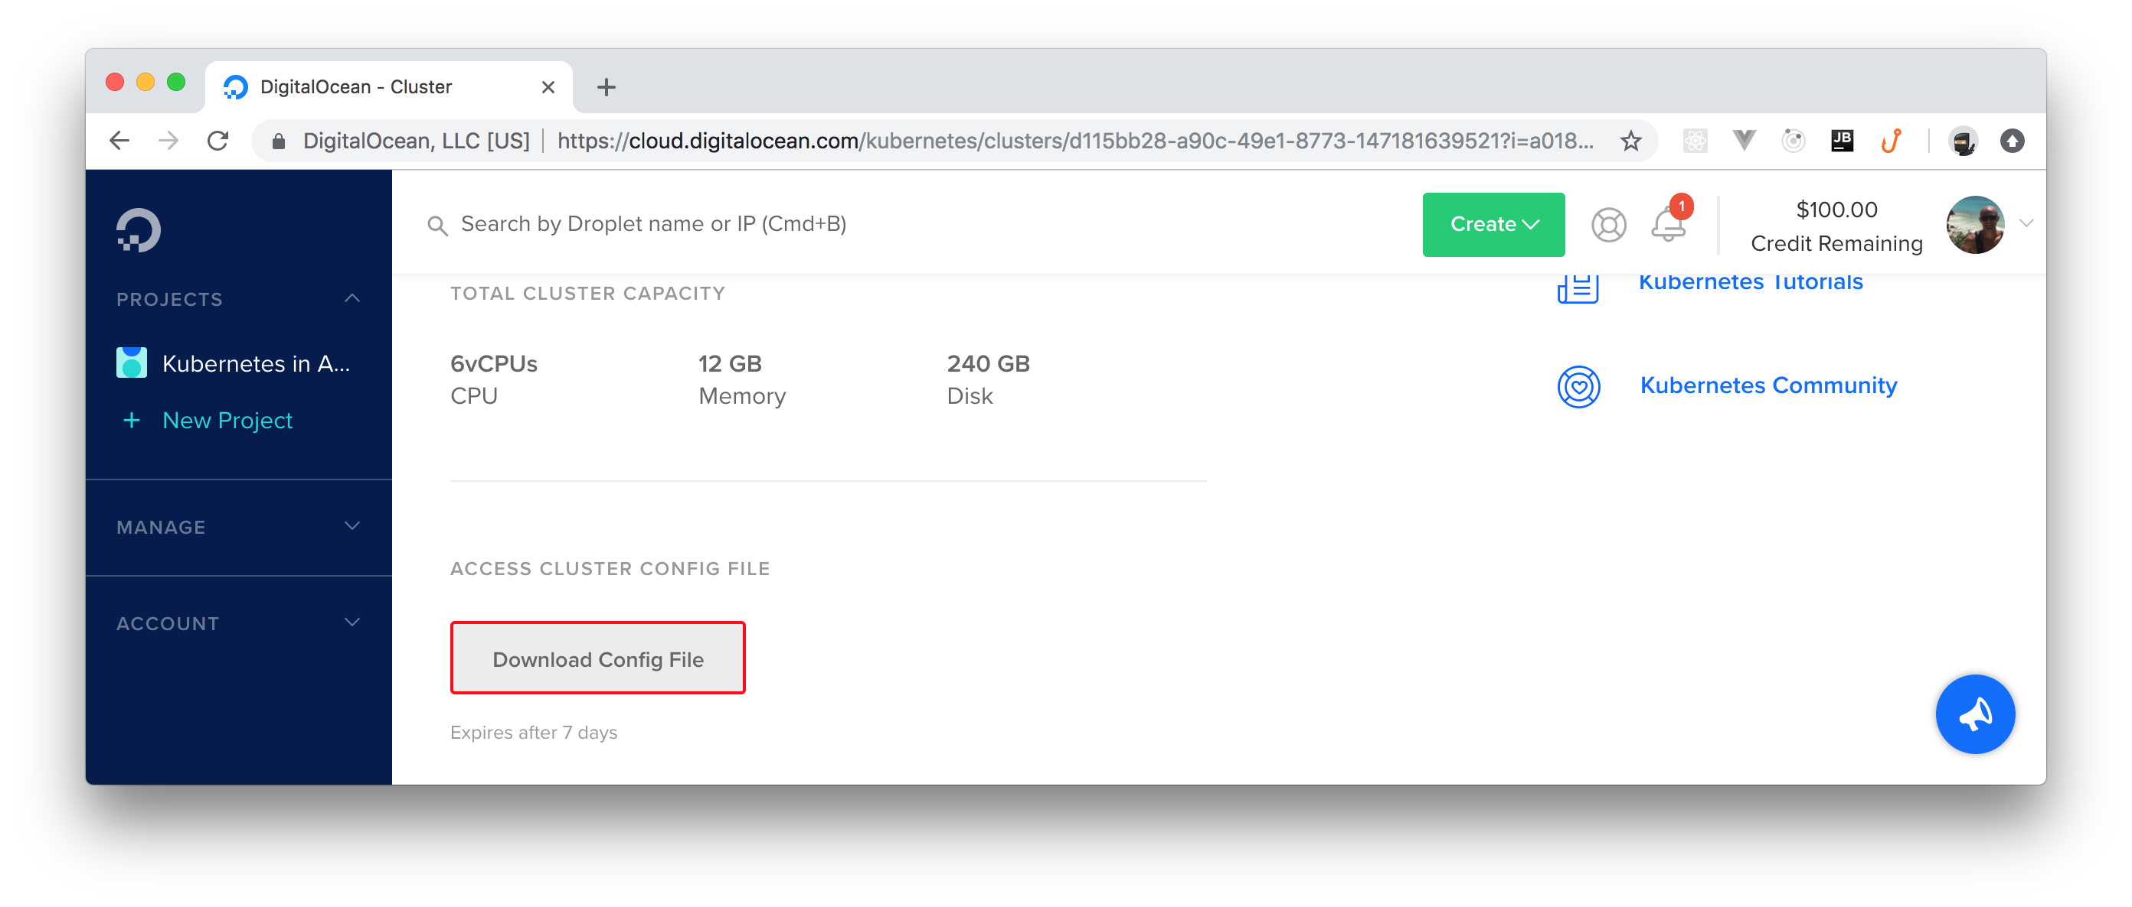
- When you finish downloading this file, open a terminal and move the file to the .kube directory in your home dir (you might have to create it):

# make sure .kube exists
mkdir ~/.kube
# move the config file to it
mv ~/Downloads/kubernetes-tutorial-kubeconfig.yaml ~/.kube

- If needed, adjust the last command with the correct path of the downloaded file.
- The ~/.kube directory is a good place to keep your Kubernetes credentials. By default, kubectl will use a file named config (if it finds one inside the .kube dir) to communicate with clusters. To use a different file, you have three alternatives:
- First, you can specify another file by using the --kubeconfig flag in your kubectl commands, but this is too cumbersome.
- Second, you can define the KUBECONFIG environment variable to avoid having to type --kubeconfig all the time.
- Third, you can merge contexts in the same config file and then you can switch contexts.
The second option (setting the KUBECONFIG environment variable) is the easiest one, but feel free to choose another approach if you prefer. To set this environment, you can issue the following command:
export KUBECONFIG=~/.kube/kubernetes-tutorial-kubeconfig.yaml
Note: Your file path might be different. Make sure the command above contains the right path. Keep in mind that this command will set this environment only on this terminal's session. If you open a new terminal, you will have to execute this command again.

How to Check the Nodes of Your Kubernetes Cluster
Now that you got yourself a Kubernetes cluster and that, you defined what credentials kubectl will use, you could start communicating with your cluster. For starters, you can issue the following command to check the nodes that compose your cluster:
kubectl get nodes
After running this command, you will get a list with three or more nodes (depending on how many nodes you chose while creating your cluster). A node, in the context of Kubernetes, is a worker machine (virtual or physical, both apply) that Kubernetes uses to run applications (yours and those that Kubernetes needs to stay up and running).
No matter how many nodes you have in your cluster, the list that the command above outputs will show the name of these nodes, their statuses (which, hopefully, will be ready), their roles, ages, and versions. Do not worry about this information now; you will learn more about nodes in a Kubernetes cluster later.
If you are seeing the list of nodes and all of them are on the ready status, you are good to go.

How to Deploy Your First Kubernetes Application
After all this setup, now it is time to deploy your first Kubernetes application. As you will see, doing so is not hard, but it does involve a good number of steps. As such, to speed up the process, instead of deploying some application that you might have around (which would need some preparation to run on Kubernetes) and instead of creating a brand new one for that, you will deploy a sample application that already exists. More specifically, you will deploy an app that allows users to share what they are thinking. Similar to what people can do on Twitter, but without authentication and way simpler.

How to Create Kubernetes Deployments
Back in the terminal, the first thing you will do is to create a directory that you will use to save a bunch of YAML files (you can name this directory anything you like, for example, kubernetes-tutorial). While using Kubernetes, you will often use this "markup language" to describe the resources that you will orchestrate in your clusters.
After creating a directory, create a file called deployment.yaml inside it and add the following code to it:

apiVersion: apps/v1
kind: Deployment

metadata:
name: kubernetes-tutorial-deployment

spec:
replicas: 2
selector:

matchLabels:
app: kubernetes-tutorial-deployment

template:
metadata:
labels:
app: kubernetes-tutorial-deployment

spec:
containers:
- name: kubernetes-tutorial-application
image: auth0blog/kubernetes-tutorial
ports:
- containerPort: 3000
- This configuration file is not hard to understand. This file is defining a deployment object kind: Deployment that creates a container named kubernetes-tutorial-application. This container uses an image called auth0blog/kubernetes-tutorial to run the sample application.
- In Kubernetes, to tell your cluster what to run, you usually use images from a registry. By default, Kubernetes will try to fetch images from the public Docker Hub registry. However, you can also use private registries if you prefer keeping your images, well, private.
- Do not worry about the other properties of this file now; you will learn about them when the time comes. However, note that the sentences in the last paragraph introduced two new concepts:
- Deployment: Basically speaking, in the context of Kubernetes, a deployment is a description of the desired state of the system. Through a deployment, you inform your Kubernetes cluster how many pods of a particular application you want running. In this case, you are specifying that you want two pods (replicas: 2)
- Container: Containers are the lowest level of a microservice that holds running applications, their libraries, and their dependencies. Containers can be exposed to the world through an external IP address and are usually part of a pod.
- Another important thing to learn about is what a pod is. A pod, as defined by the official documentation, is the smallest deployable unit of computing that can be created and managed in Kubernetes. For now, think of pods as groups of microservices (containers) that are so tightly related they cannot be deployed separately. In this case, your pods contain a single container, the sample application.
Note: Nowadays, deployments are the preferred way to orchestrate pods and replication. However, not that long ago, Kubernetes experts used to use Replication Controllers and Replication Sets. You do not need to learn about these other objects to follow along with this tutorial. However, if you are curious, you can read about their differences in this nice resource.

- Then, to run this deployment in your Kubernetes cluster, you will have to issue the following command:
# make sure you are inside the kubernetes-tutorial directory
kubectl apply -f deployment.yaml
- After running this command, your cluster will start working to make sure that it reaches the desired state. That is, the cluster will make an effort to run both pods replicas: 2 on your cluster's nodes.
- After that, you might be thinking, "cool, I just deployed a sample application into my cluster, now I can start using it through a browser". Well, things are not that simple. The problem is that pods are unreliable units of work that come and go all the time. As such, due to its ephemeral nature, a pod by itself is not accessible by the outside world.
- In the previous command, you informed your cluster that you want two instances (pods) of the same application running. Each one of these pods has a different IP address inside your cluster and, if one of them stops working (for whatever reason), Kubernetes will launch a brand new pod that will get yet another IP address. Therefore, it would be difficult for you to keep track of these IP addresses manually. To solve this problem, you will use Kubernetes' services.
Note: Another situation that might make Kubernetes launching new pods for your deployments is if you ask your cluster to scale your application (to be able to support more users, for example).

- However, before learning about services, issue the following command to confirm that your pods are indeed up and running:
kubectl get pods
By issuing this command, you will get a list of the available pods in your Kubernetes cluster. On that list, you can see that you have two pods (two rows) and that each pod contains one container (the 1/1 on the Ready column). You can also see their statuses, how many times they restarted (hopefully, zero), and their age.
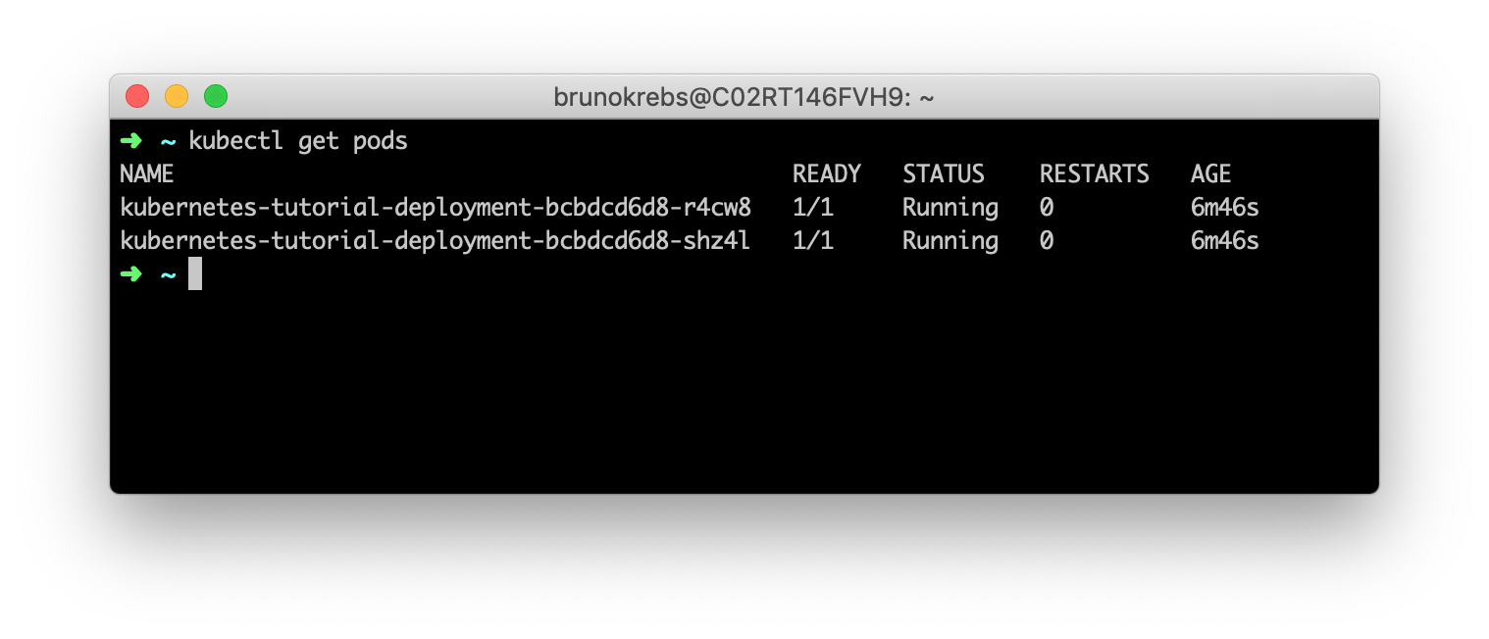

Using Services and Ingresses to Expose Deployments
- After learning about pods, deployments, and containers, you probably want to consume your new deployment, right. To do so, you will need to create ingress rules that expose your deployment to the external world. Kubernetes ingress is an "object that manages external access to services in a cluster, typically through HTTP". With ingress, you can support load balancing, TLS termination, and name-based virtual hosting from within your cluster.
- To configure ingress rules in your Kubernetes cluster, first, you will need an ingress controller. As you can see here, there are many different ingress controllers that you can use. In this tutorial, you will use one of the most popular, powerful, and easy-to-use ones: the NGINX ingress controller.

- The process to install this controller in your cluster is quite simple. The first thing you will have to do is to run the following command to install some mandatory resources:
kubectl apply -f https://raw.githubusercontent.com/kubernetes/ingress-nginx/master/deploy/static/mandatory.yaml

- Then, you will have to issue this command to install another set of resources needed for the controller:
kubectl apply -f https://raw.githubusercontent.com/kubernetes/ingress-nginx/master/deploy/static/provider/cloud-generic.yaml
Note: If you are running your Kubernetes cluster on a service other than DigitalOcean, you will probably need to run a different set of commands. Please, check out this resource to learn more about the differences.

- To confirm that the above commands worked, you can issue the following command:
kubectl get pods -n ingress-nginx
- This command should list a pod called nginx-ingress-controller-. with the status equals to running. The -n ingress-nginx flag passed to this command states that you want to list pods on the ingress-nginx namespace. Namespaces are an excellent way to organize resources in a Kubernetes cluster. You will learn more about this Kubernetes feature in another opportunity.

- Having configured the ingress controller in your cluster, the next thing you will do is to create a service. Wait, a service? Why not an ingress?
- The thing is, as your pods are ephemeral (they can die for whatever reason or Kubernetes can spin new ones based on replication rules), you need a static resource that represents all the related pods as a single element (or, in this case, that represents the deployment responsible for these pods). When you define a service for your pods, you will be able to create ingress rules that point to this service.
- What you will need now is a ClusterIP service that opens a port for your deployment.
- To create one, create a file called service.yaml and add the following code to it:

apiVersion: v1
kind: Service
metadata:
name: kubernetes-tutorial-cluster-ip
spec:
ports:
- port: 80
protocol: TCP
targetPort: 3000
selector:
app: kubernetes-tutorial-deployment
type: ClusterIP

Note: There are many different types of services available on Kubernetes. ClusterIP, the type you are using, helps you expose your deployments inside the cluster only. That is, this kind of service does not expose deployments to the outside world. There are other types that do that for you (you can learn about them here) but, on this series, you will be not using them.

- Then, you can issue the following command to create this service in your cluster:
kubectl apply -f service.yaml
- After running this command, Kubernetes will create a service to represent your deployment in your cluster. To know that this service works as a broker for this deployment in particular (or for its pods, actually), you added the selector.app property on the service description service.yaml pointing to kubernetes-tutorial-deployment. If you take a look again on the deployment.yaml file, you will notice that you have there a property called labels.app with the same value kubernetes-tutorial-deployment. Kubernetes will use these properties to tie this service to the deployment's pods.
- Another important thing to notice about the service you are creating is that you are defining that this service will listen on port:80 and that it will targetPort: 3000 on pods. If you check your deployment file, you will see that you defined that your containers will use this port containerPort: 3000. As such, you must make sure that your service will target the correct port when redirecting requests to your pods.

Note: If you run kubectl get svc now, your cluster will list two services. The first one, called kubernetes, is the main service used by Kubernetes itself. The other one is the one you created: kubernetes-tutorial-cluster-ip. As you can see, both of them have internal IP addresses CLUSTER-IP. However, you will not need to know these addresses. As you will see, ingresses allow you to reference services more cleverly.

- After creating your service, you can finally define an ingress (and some rules) to expose this service (and the deployment that it represents) to the outside world.
- To do this, create a file called ingress.yaml with the following code:

apiVersion: extensions/v1beta1
kind: Ingress
metadata:
name: kubernetes-tutorial-ingress
spec:
rules:
- http:
paths:
- path: /
backend:
serviceName: kubernetes-tutorial-cluster-ip
servicePort: 80
In this file, you are defining an ingress resource with a single rule spec.rules. This rule tells Kubernetes that you want requests pointing to the root path path: / to be redirected to the kubernetes-tutorial-cluster-ip service (this is the name of the service that you created before) on port:80 servicePort: 80.

- To deploy the new ingress in your cluster, you can issue the following command:
kubectl apply -f ingress.yaml

- Then, to see the whole thing in action, you will need to grab the public IP address of your Kubernetes cluster. To do so, you can issue the following command:
kubectl get svc \
-n ingress-nginx ingress-nginx \
-o=jsonpath='{.status.loadBalancer.ingress[0].ip}'

Note: On the command above, you are using a Kubernetes feature called JSONPath to extract the exact property you want from the ingress-nginx service (in this case, its public IP address). Learn more about the JSONPath feature here.
This command will output an IP address (Ex:104.248.109.181) that you can use in your browser to see your application. Therefore, if you open your browser and navigate to this IP address, you will see the sample application you just deployed.
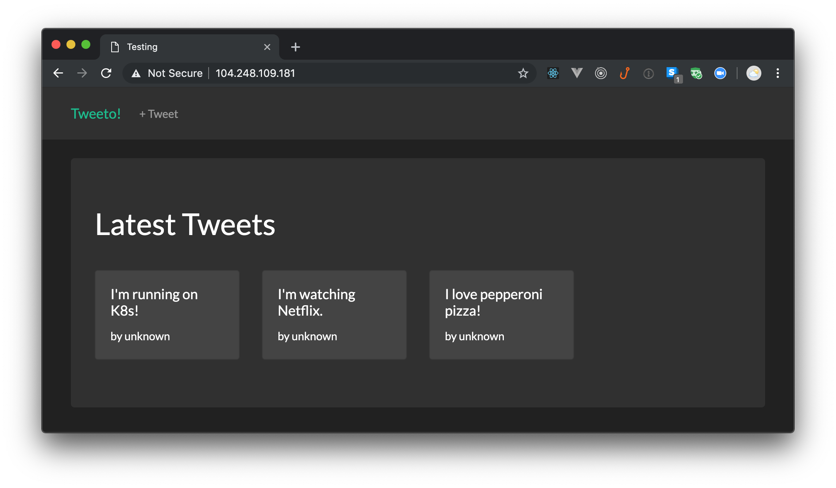
Note: This application is not very useful, it just emulates a much simpler Twitter application where users can share their thoughts. The app does not even have an identity management (user authentication) system.

That's it! You just finished configuring your local machine to start working with Kubernetes, and you just deployed your first application on Kubernetes. How cool is that?

Note: To avoid spending the whole credit DigitalOcean gave you, you might want to delete your cluster soon. To do so, head to the Kubernetes section of your DigitalOcean dashboard, click on the More button on the right-hand side of the screen and click on Destroy. DigitalOcean will ask you to confirm the process.
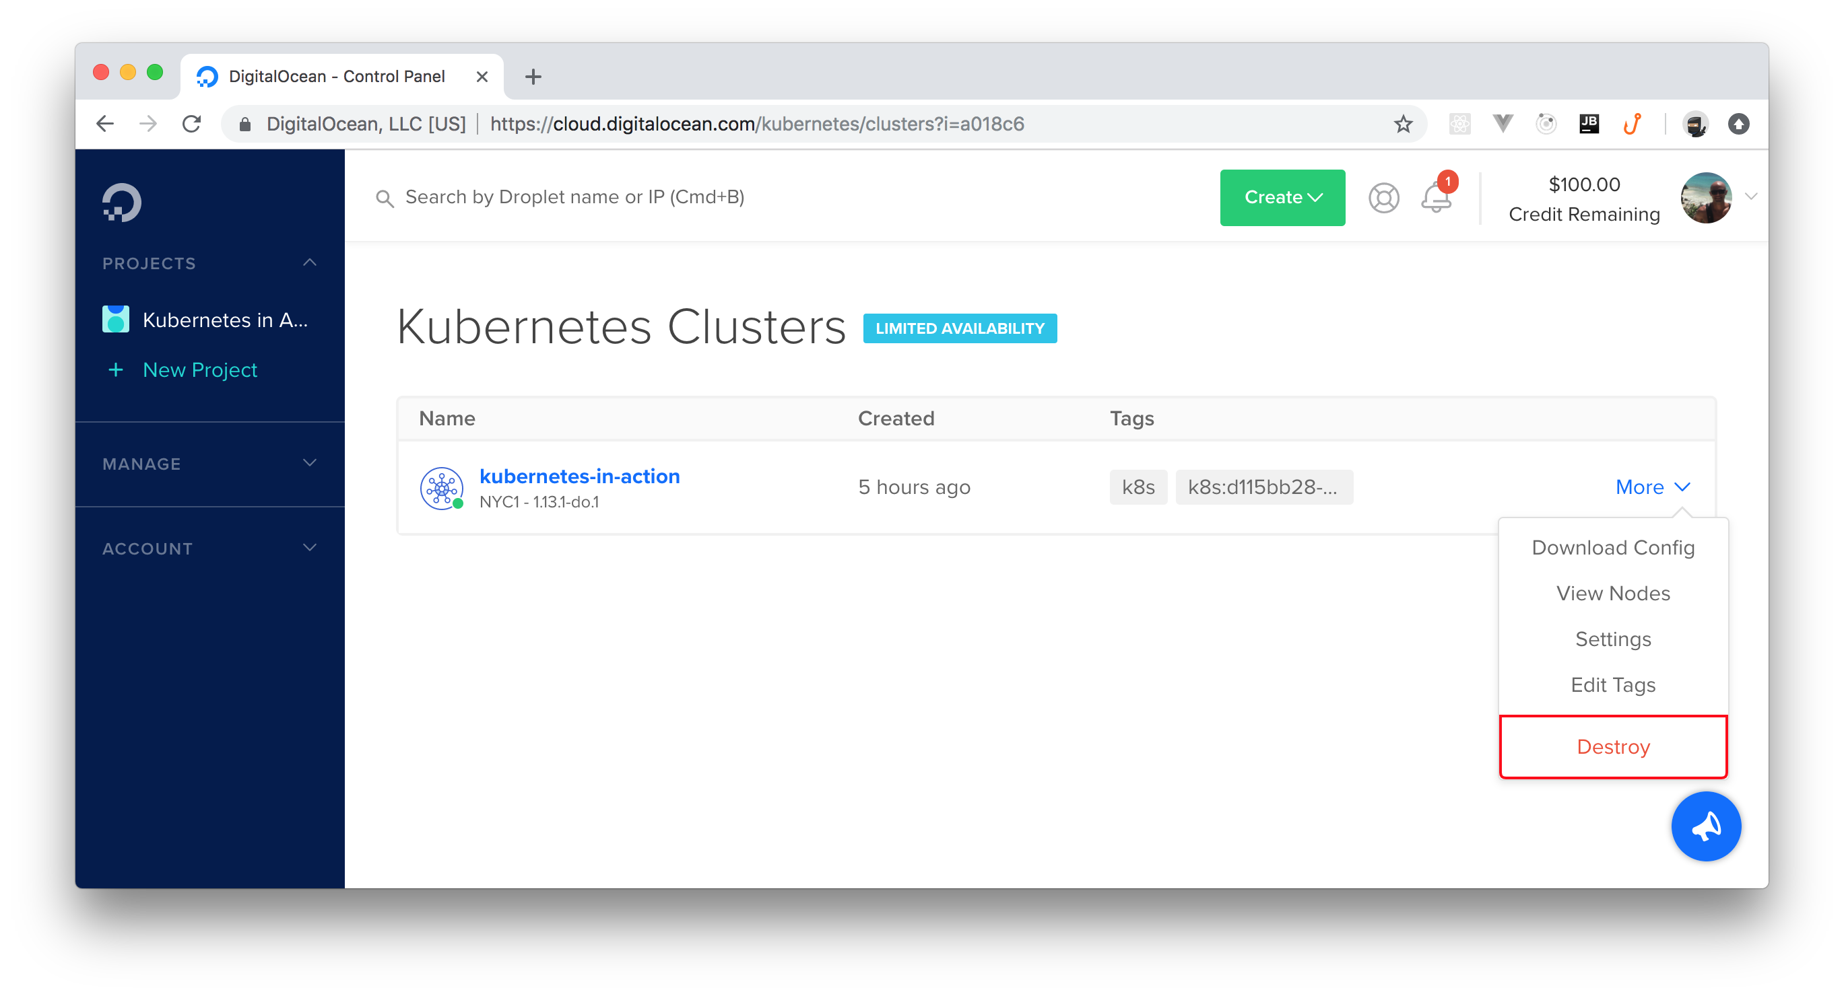

"I just deployed my first Kubernetes application. So easy!!!"

